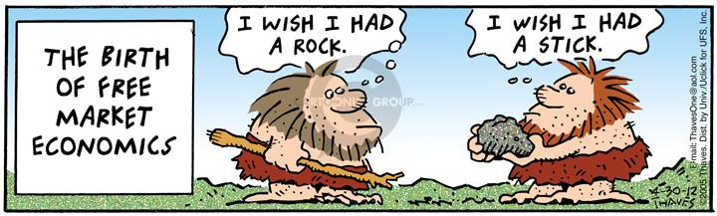
Unit 3
Factors of Production, Thinking at the Margin, and
Production Possibilities
(Lessons 11, 12, 13, 14, and 15)

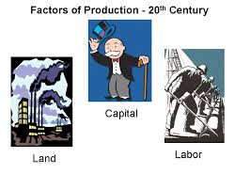
Lesson 11
Factors of Production
(36 points)
Review:
- Why are institutions important?

- What are examples of institutions?

- What are incentives?

- What are the two types of incentives?

- What are examples of each?

- What is profit?

- How is profit an incentive in business?

- How is “profit” an incentive in class?

- How were incentives used in Obamacare?

- How are incentives being used to encourage use of ethanol and discourage fossil fuels?

- What are the two types of products?

New key terms:
- Factors of production:

- Land:

- Labor:

- Capital:

- Human capital:

- Physical capital:

- Factor payments:

- Entrepreneurship:

- Intermediaries:
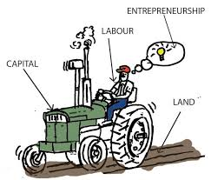

Class notes:
- What is the significance of the factors of production?

- How does this “recipe” vary?

- What are examples of how this “recipe” varies?

- Where do the businesses secure the factors and from whom?

- How can we diagram the factor market?

- Why do households provide the factors?

- What are examples of factor payments?

- What do businesses do with the factors of production?

- What do households use the factors payments for?

- What do factor payments include?

- Where do these transactions take place?

- How can we diagram the product market?

- What role do intermediaries play in the factor market?

- What role do intermediaries play in the product market?

- How do teachers such as Mr. Lopez participate in the factor market?

- How do individuals such as Mr. Lopez participate in the product market?

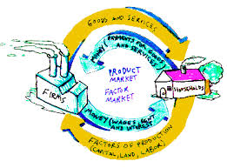
Lesson 12
Factor and Product Market
(25 points)
Review:
- What is a market?

- What are examples of markets?

- What is the purpose of a market?

- What are the factors of production?

- What is the significance of these factors?

- What are the two types of capital?

- Why do Mr. Lopez and many economists disagree with the idea that entrepreneurship is a factor of production?

- What occurs in the factor market?

- What occurs in the product market?

New key terms:
- Specialization:

Factor Market Activity:
- In preparing for this activity, how was the class divided?

- How were the resources allocated to the households and how does this allocation reflect the reality?

- What resources did the businesses initially have?

- How did the businesses seek to satisfy their needs and wants?

- How did the households seek to satisfy their needs and wants?

- What part of our activity represented the factor market?

- What part of our activity represented the product market?

- What motivation did the households have in selling the factors of production?

- What motivation does Mr. Lopez have in selling his factors of production?

- How successful were the businesses and why did their success vary?

- Why might some households have factors remaining after the activity?

- Why might individuals in the real world have factors that are “undesired”?

- What pricing strategy for the businesses selling their goods and/or services could have been adopted in order to ensure profit?

- What risk did the business owners assume during our activity?

- How have recent changes in the cost if resources affected the airline industry and how have airlines responded?

Lesson 13
Specialization
(52 points)
Review:
- What is a business?

- What is a household?

- What is specialization?
- How did the activity in our last class illustrate the factor market?

- How did our activity in our last class illustrate the product market?

- Why are the factors of production important?

- What is entrepreneurship?

- Why do I disagree with those who identify four factors of production?

- What are the two types of capital?

- What are factor payments?

- What do factor payments include?

- What actually is the opportunity cost of missing any portion of this class?

New key terms:
- Normal goods:

- Inferior goods:

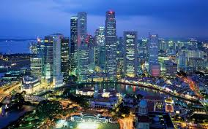
Class notes:
- How did Jimmy Smith’s video illustrated the advantages of specialization?

- How do a nation’s factors of production influence how they specialize?

- Use opportunity cost to explain why its to the US advantage to have our socks, Tshirts, and underwear manufactured overseas.

- Identify two countries/states with significant “land” resources.

- Identify two countries/states with significant labor resources.

- Identify two countries/states with significant capital resources.

- Identify two countries/states with scarce land or natural resources.

- Identify two countries/states with scarce labor resources.

- Identify two countries/states with scarce capital resources.

- What advantages and disadvantages does Hong Kong have and how has this influenced their specialization?

- What advantages and disadvantages does Saudi Arabia have and how has this influenced their specialization?

- What advantages and disadvantages does Bangladesh have and how has this influenced their
specialization?

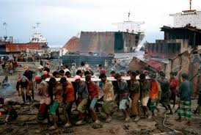
“Shipbreakers” video:
Answer the following questions while viewing the video on shipbreakers:
- How is the purpose of the “shipyards” in Bangladesh different from shipyards in the west?

- How did Bangladesh become a place for dismantling ships?

- Approximately how many shipyards are operating on this 10 mile stretch of beach?

- Approximately how many ships are dismantled in these shipyards each year?

- Approximately how many people are employed in the shipyards and what is their daily wage?

- Why are these shipyards so important to Bangladesh?

- What incentive do shipping companies have for using these yards?

- What would these companies have to do if they dismantled the ships in the United States or Europe?

- What contributes to the “efficiency” of how everything on these ships is “recycled”?

- Why did the owner of the PHP Company purchase a ship for $14 million that is being “retired”?

- How can he make a $14 million purchase sight unseen?

- Why are some westerners opposed to what is taking place?

- What incentive do workers have to undertake this difficult job?

- Why do children take these jobs and how can their employers justify using them?

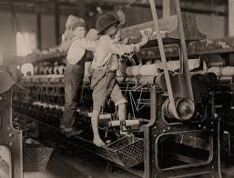
- Compare and contrast this current use of child labor illustrated in this video with that in the United States during the 1800s?

- Use opportunity cost to explain why the crew left pots of food in the dining room of the Russian ship.

- If this operation is violating various laws, why do you think the government permits it to continue?

- Use opportunity cost to defend the actions of the employers.

- Why is it actually more “efficient” to have this work performed on this coast than in the US, Russia, or Europe?

Paper Plane Specialization Activity:
Paper airplane activity:
- How did our paper airplane activity illustrate the advantage of specialization?

- How might businesses use specialization in the workplace to improve productivity and efficiency?
  - Data Processing:

  - Assembly line:

  - Accounts receivable:

  - “Experts”

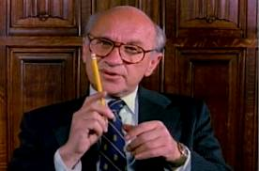
- What is a market?

- What is the advantage of markets?

- How do markets encourage specialization?

- How did the video on “pencils” illustrate specialization?

- How did the video illustrate the role of markets in bringing resources together?

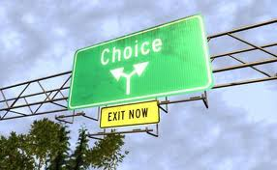
Lesson 14
Thinking at the Margin
(60 points)
Review:
- What is specialization?

- What is the definition of economics?

- What are trade offs?

- What are opportunity costs?

- Why are rich and famous people more likely to get a divorce?

- What occurs in the factor market?

- What occurs in the product market?

- What are normal goods and examples of stores that sell them?

- What are inferior goods and examples of stores that sell them?

Key Terms:
- Thinking at the margin?

- Marginal benefit:

- Marginal cost:

- Net marginal benefit:

- Law of diminishing returns:

- Sunk costs

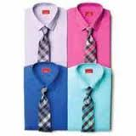
Introduction:
- When I go shopping at a Macy’s “One Day Sale”, when given 6 shirts as trade offs, how do I decide which shirt to buy?

- If I decide to purchase a second shirt, how do make this choice?

- What can I say regarding the “value” I assign to these two shirts?

- How does a sale offering a second item at half price reflect this reality?

- What can we say if after selecting two shirts to buy I decide to buy a pair of purple socks?

- BTW, why is there a round Macy’s in Queens NY?

- Why does Macy’s principal store in Manhattan look like it has a slice missing?

Eating “Love Strawberries”
- What is scarcity?

- What methods can we use to allocate scarce resources, in this case Lopez’s love strawberries?

- In our recent “Ice Activity “, what two methods did we use?

- Of the two methods used in that activity which was most beneficial to our “society” and why?

- How does this method get the product or resource to the person that values it the most?

- Why are we eating strawberries today?

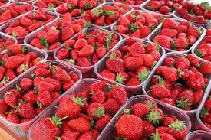
Spraying Strawberries Activity:
29.
Number of Hires | Total Benefits  (Total $ Crops Saved) | Marginal Benefits (MB)  ($ of add’l crops saved) | Marginal Cost (MC)  ($ of add’l hire) | New Marginal Benefit  MB-MC=NMB
1 | $100 | $100
2 | $200
3 | $270
4 | $330
5 | $382
6 | $420
7 | $450
8 | $460
9 | $460
10 | $455
Class notes:
- What occurred during this activity?

- What does “thinking at the margin mean”?

- What is marginal cost?

- What is marginal benefit?

- How can we use marginal cost/benefit in decision making?

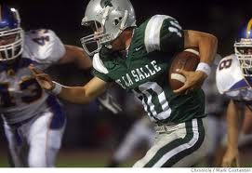
- Using football as an example of thinking at the margin?

- Using store hours as an example?

- At what time do you close your store or restaurant?

- Use studying for an exam as an example?

- How do we determine how many additional troops to send to Afghanistan?

- How do we determine how many days to remain in Afghanistan?

- By staying in Afghanistan, what can we say about the cost in lives and wealth?

- Why is North Korea and Iran attempting to build atomic weapons?

- What is the Law of diminishing returns?

- What are some examples of the Law of Diminishing returns?

- What is the connection between thinking at the margin, satisfaction, and trade offs?

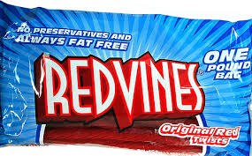

- How did we use candy to illustrate the Law of Diminishing Returns?

- What other examples did we use?

- How did we use candy to illustrate the connection between thinking at the margin, satisfaction, and trade offs?

- How many times did we spray the strawberries?

- How did we make this decision?

- How did this activity illustrate the Law of Diminishing Returns?

- For each of the following use marginal benefit/marginal cost to determine:
  - How many days we should bomb a German city during World War II?

  - How many face lifts should a person receive?

  - How many seat belts or air bags to include in a new car?

  - How much should we spend cleaning up pollution?

  - How often to date a person?

- Why isn’t Mr. Lopez concerned over cuts in Federal Homeland Security Funding to NYC?

- Why is it actually less “satisfying” to increase funding for government programs?

- Why does Mr. Lopez advise never ordering Lobster on a first date?

- What kind of dates do the people on “The bachelor” go on?

- Why is the opportunity cost of these dates “low”?

- Why might these dates make a long lasting relationship more difficult once the show is over?

- Why do children generally increase the marginal benefit of a marriage?

- What is the relationship between thinking at the margin and opportunity cost?

Side Note: In Oakland: Bakesale Betty’s
5098 Telegraph Ave, Get off 24 at Telegraph go left 4 or 5 blocks on left side.
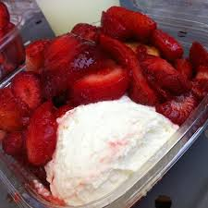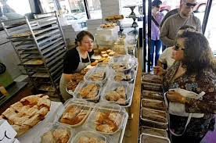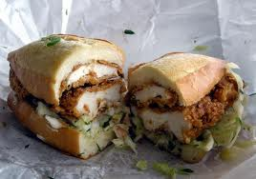

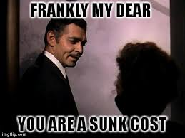
Lesson 15
Sunk costs
(25 points)
Review:
- What does thinking at the margin mean?

- What is marginal cost?

- What is marginal benefit?

- How do we use MB and MC in decision making?

- What is the law of diminishing returns?

- How did we use students to illustrate the law of diminishing examples?

- Why not order lobster on a first date?

- What are sunk costs?

New key terms:
- Utility

Sunk cost activity:
- What was being auctioned?

- At what price did the bidding start?

- What was the reason for the initial bids?

- At what point did the bidding become a losing proposition?

- What was the incentive for why the participants continued bidding?

Class notes:
- How can sunk cost be an incentive?

16. What is an example of how sunk costs can be a disincentive to “cheat”?

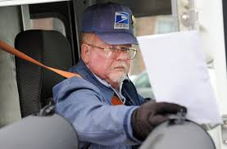
17. What is an example of how sunk costs can be a disincentive to change careers?

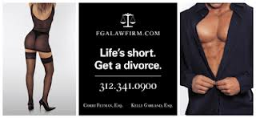
18. Why do some people stay in a “bad” relationship or marriage?

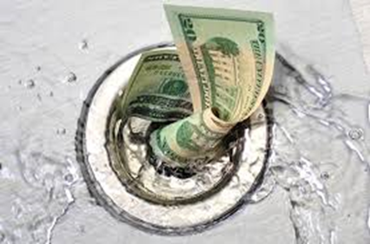
19. What is an example of how sunk costs can be an incentive for government spending?

20. Why do some economists believe The Head Start Program is an example of this?

21. Why is military spending on weapons systems sometimes also an example of this?

22. How can the concept of sunk costs be used to explain why the US might be staying in Afghanistan?

23. Use sunk costs to explain why the President recently sent 300 plus soldiers back into Iraq?

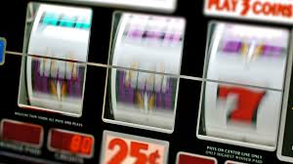

24. How does this demonstration also illustrate situations that commonly occur in casinos?

- How does a company know how many additional works to hire on an assembly line?

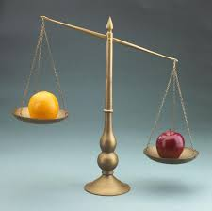
Lesson 16
Production Possibilities
(76 points)
Review:
- What is opportunity cost?

- Why can it be said that nothing is free”

- What is thinking at the margin?

- How does thinking at the margin relate to opportunity costs?

- What are sunk costs?

- How does sunk cost sometimes influence our decision making?

- What is utility?

- What is the law of diminishing returns?

New key Terms:
- Production Possibilities Schedule:

- Production Possibilities Graph:

- Law of increasing cost:

Introduction:
- .Why has the increased use of corn ethanol resulted in a drop in the production of soybeans?

- What would be the opportunity cost of increasing soybean production?

Class notes:
- What information does a production possibilities schedule provide?

- What is the difference between a production possibilities schedule and a production possibilities graph?

- Why do we only use two alternatives in a production possibilities schedule/graph?

- Production Possibilities Schedule from the power point example:

Flip Flops | Watermelons

- Production possibilities graph from the power point example:

- What are the two most “extreme” possibilities?

- What happens as we increase the production of one of these two items?

- What is the law of increasing cost?

- What is an example of the law of increasing cost from the example above?

- What is the relationship of the law of increasing cost to opportunity cost?

- Where would underutilization occur? Indicate a point where there would be underutilization by placing a dot in your production possibilities graph for watermelons and flip flops?.

- What might occur if a new more productive technique for producing (growing) watermelons was developed?

- What affect would this new technique have on a production possibilities schedule?

- What affect would this new technique have on a production possibilities graph?

- Why would there be a greater incentive to grow watermelons?

- What would happen to our incentive to produce flip flops?

- How can we use opportunity cost to explain what occurred to the production of producing flip flops?

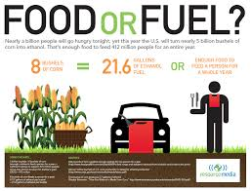
Example “B” Ethanol:

- What is corn ethanol?

- Why is growing soybeans an opportunity cost for growing corn?

- What are the primary uses of corn?

- Why is demand for ethanol increasing?

- What affect would a government subsidy or payment to farmers who grow corn have on the production of soybeans?

- In addition to a subsidy what other “incentive” has government created for growing corn to be used for ethanol?

- What affect would these subsidies have on the opportunity cost of growing soybeans?

- What has been the result?

- In creating a production possibilities schedule/graph for corn versus soybeans, what would be the two most “extreme” possibilities?

- Assuming you plan to plant 200 acres this year, in some combination of corn and/or soybeans, complete the following production possibilities schedule for corn and/or soybeans:

Corn | Soybeans

- Production possibilities graph for corn and/or soybeans schedule:

- What happens as we increase the production of one of these two possibilities?

- What would be the cost of increasing the production of corn from 100 acres to 15t0 acres?

- Using this production possibilities schedule for corn or soybeans, what is a example of the law of increasing cost?

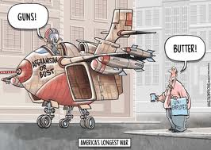
Example “C” Guns or butter:
- What does the term “guns or butter” refer to?

- What are the two most “extreme” possibilities in choosing between guns or butter?

- Why is the opportunity cost of producing “guns” butter?

- Assuming the government of a small nation has to decide how to allocate $100 million dollars between military and non-military expenditures, complete the following production possibilities schedule showing this possible allocation.

“Guns”  ( ) | “Butter”  ( )

- What affect does a war or prolonged military action typically have on the production of guns in a society?

- What is the “cost” of this production choice?

- Production possibilities graph for the schedule on guns and/or butter:

- On each of the graphs above, label the production possibilities frontier.

- Why isn’t it possible to have a level of production above the line on the graph above?

- What would have to occur for this level of production to be possible?

- Where would underutilization occur on the graphs above? Place a dot to show a level of production that illustrates underutilization.

- How have some companies used “outsourcing” to achieve levels formerly not possible?

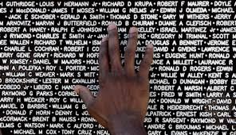
- Why do many economists believe a war must be the lesser of two evils?

- What overall affect does a war ultimately have on a production possibilities schedule and/or graph?

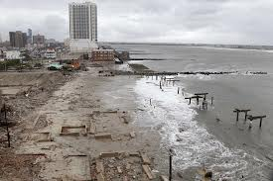
- Why do economists disagree as about the “benefits” of a disaster to an economy?
- What overall affect does a disaster have on a production possibilities schedule and/or graph?

- What does Mr. Lopez say regarding wars and disasters and the use of resources to rebuild afterwards?

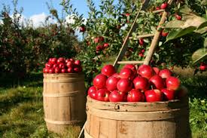
Specialization and Production Possibilities:
- What is specialization?

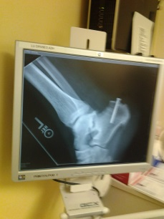
- Why is a surgeon an example of specialization?

- How a high school teacher an example of specialization?

- How is Napa California an example of specialization?

- What is the relationship of specialization and efficiency?

- How does society benefit from specialization?

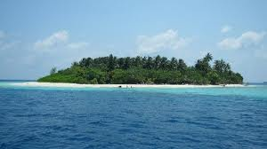
Production Possibilities and Robinson Crusoe and Friday (The benefit of Specialization):
- Production possibilities schedule for Robinson C and Friday:

Robinson C.
Fish | Coconuts

Friday
Fish | Coconuts
- Production possibilities graph for Robinson C. and Friday:

- What should Robinson C. specialize in?

- What should Friday specialize in?

- How do some nations specialize?

- How does the United States specialize?

- How does China specialize?

- Production possibilities for the US and China:

- If given a choice between manufacturing or producing goods and the alternative of producing services, what advantages does China have over the United States and visa versa?

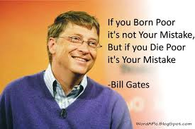
Unit 4
Entrepreneurs
(Lessons 16, 17, and 18)

Lesson 16
Entrepreneurs
(26 points)
Review:
- Entrepreneurship:

New key terms:
- Entrepreneurs:

- Stock:

- Options:

Class notes:
- Who are entrepreneurs?

- Why are they important?

- What is the risk?

- Why do they assume this risk?

- What does stock actually represent?

- How can stock make you rich?

- Why did Lopez’s rabbit business fail?

- How did this “failure” demonstrate the need for human capital in entrepreneurship/business?

- What other two ventures did Lopez start when he was young?

- What was the risk in each of these ventures?

- Where was the profit he was seeking in each of these ventures?

- Why did Lopez become an entrepreneur as an adult?

- What were other examples of Lopez as an entrepreneur?

- Why did Lopez pull the plug on his 3-D business?

- Why was Lopez’s internet business very “successful”?

- What do a large number of economists and economics professors believe?

- Why does Mr. Lopez disagree with them?

- What examples does he give?

- What does Mr. Lopez argue about Entrepreneurship?

- How can opportunity cost explain why Entrepreneurs such as Bill Gates and Ray Kroc frequently choose not to complete their college education?

- How can opportunity cost explain why entrepreneurs usually get started part time or working at night?

- What might you find late at night at a 24 hour copy and/or computer center?

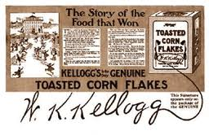
Lesson 17
Entrepreneurs
“The Kellogg Brothers”
(24 points)

While watching the video on the life of the Kellogg Brothers, answer the following questions.
1. How was Kellogg’s life influenced by his religious faith?

2. What was water therapy?

3. How would you describe the health of most Americans in the late 1800s?

4. How did “business” respond to the ills of most Americans of the late 1800s?

5. What was the Sands?

6. Describe a typical visit the Sands?

7. What were a few examples of how the Sands sought to use High tech to improve health?

8. How successful was the Sands and why did he hire his brother?

9. What did Kellogg believe about meat eating and how did he seek to scare people away from meat?

10. What was The Red Onion Tavern?

11. What did he determine by studying animals in a zoo?

12. How did Kellogg incorporate music into good health?

13.Why did Kellogg refuse to capitalize (make money) on his inventions?

14. What famous food did Kellogg invent, patent, but fail to capitalize on?

15. What was Kellogg’s attitude toward sex?

16. How did Kellogg seek to use the children he adopted to prove his theories?

17. What was the Race Betterment Society?

18. How did Shredded Wheat lead to the invention of corn flakes?

19. Who was the first individual to make a fortune using Kellogg’s cereal discoveries? What was this man’s cereal product?

20. What effect did cereal have on Battle Creek, Michigan and why?

21. What was the unpardonable sin that Kellogg’s brother had committed?

22. How did Kellogg feel about his brother’s cereal business?

23. Why did Kellogg add his signature to his cereal boxes?

24. How did the Great Depression affect each of the brothers?

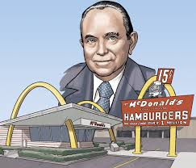
Lesson 18
Entrepreneurs
“Ray Kroc”
(13 points)

Answer the following questions while viewing the video on Ray Kroc:
- Use opportunity cost to explain why after Ray Kroc returned to school after World War II he ultimately dropped out of school.

- How did Ray Kroc get started in sales?

- How did he get soda shops to buy his paper cups?

- Why did his family life and marriage suffer?

- Why did he change careers to start selling milkshake machines?

- What risk did he take in changing careers?

- How did the growth of suburbs affect the soda shop industry?

- Why did the hamburger shop owned by the McDonald brothers attract his attention?

- What unexpected cost did he have to incur in “buying” the McDonald’s brand?

- How did he seek to profit from the sale of franchises?

- How did he ultimately learn to make money from franchising?

- Why did he ultimately find he had to buy out the McDonald brothers and how did he feel about paying them what they demanded?

- Why didn’t his buy out of the two brothers end his disputes with them and what did he ultimately do to drive them out

