Liberty High School
Economics
Mr. Lopez

Name:__________________________ Period:_______
Unit 3
Factors of Production, Thinking at the Margin, and
Production Possibilities

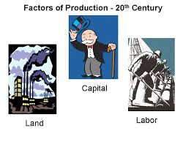
Factors of Production
Review:
- Why are institutions important?

- What are examples of institutions?

- What are incentives?

- What are the two types of incentives?

- What are examples of each?

- What is profit?

- How is profit an incentive in business?

- How is “profit” an incentive in class?

- How were incentives used in Obamacare?

- How are incentives being used to encourage use of ethanol and discourage fossil fuels?

- What are the two types of products?

New key terms:
- Factors of production:

- Land:

- Labor:

- Capital:

- Human capital:

- Physical capital:

- Factor payments:

- Entrepreneurship:

- Intermediaries:
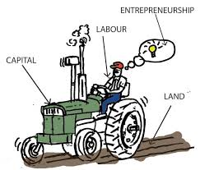

Class notes:
- What is the significance of the factors of production?

- How does this “recipe” vary?

- What are examples of how this “recipe” varies?

- Where do the businesses secure the factors and from whom?

- How can we diagram the factor market?

- Why do households provide the factors?

- What are examples of factor payments?

- What do businesses do with the factors of production?

- What do households use the factors payments for?

- What do factor payments include?

- Where do these transactions take place?

- How can we diagram the product market?

- What role do intermediaries play in the factor market?

- What role do intermediaries play in the product market?

- How do teachers such as Mr. Lopez participate in the factor market?

- How do individuals such as Mr. Lopez participate in the product market?

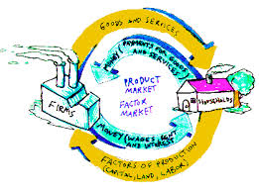
Factor and Product Market
)
Review:
- What is a market?

- What are examples of markets?

- What is the purpose of a market?

- What are the factors of production?

- What is the significance of these factors?

- What are the two types of capital?

- Why do Mr. Lopez and many economists disagree with the idea that entrepreneurship is a factor of production?

- What occurs in the factor market?

- What occurs in the product market?

New key terms:
- Specialization:

Factor Market Activity:
- In preparing for this activity, how was the class divided?

- How were the resources allocated to the households and how does this allocation reflect the reality?

- What resources did the businesses initially have?

- How did the businesses seek to satisfy their needs and wants?

- How did the households seek to satisfy their needs and wants?

- What part of our activity represented the factor market?

- What part of our activity represented the product market?

- What motivation did the households have in selling the factors of production?

- What motivation does Mr. Lopez have in selling his factors of production?

- How successful were the businesses and why did their success vary?

- Why might some households have factors remaining after the activity?

- Why might individuals in the real world have factors that are “undesired”?

- What pricing strategy for the businesses selling their goods and/or services could have been adopted in order to ensure profit?

- What risk did the business owners assume during our activity?

- How have recent changes in the cost if resources affected the airline industry and how have airlines responded?

Lesson 13
Specialization
(52 points)
Review:
- What is a business?

- What is a household?

- What is specialization?

- How did the activity in our last class illustrate the factor market?

- How did our activity in our last class illustrate the product market?

- Why are the factors of production important?

- What is entrepreneurship?

- Why do I disagree with those who identify four factors of production?

- What are the two types of capital?

- What are factor payments?

- What do factor payments include?

- What actually is the opportunity cost of missing any portion of this class?

New key terms:
- Normal goods:

- Inferior goods:

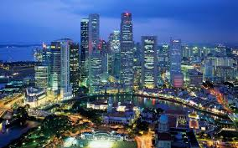
Class notes:
- How did Jimmy Smith’s video illustrated the advantages of specialization?

- How do a nation’s factors of production influence how they specialize?

- Use opportunity cost to explain why its to the US advantage to have our socks, Tshirts, and underwear manufactured overseas.

- Identify two countries/states with significant “land” resources.

- Identify two countries/states with significant labor resources.

- Identify two countries/states with significant capital resources.

- Identify two countries/states with scarce land or natural resources.

- Identify two countries/states with scarce labor resources.

- Identify two countries/states with scarce capital resources.

- What advantages and disadvantages does Hong Kong have and how has this influenced their specialization?

- What advantages and disadvantages does Saudi Arabia have and how has this influenced their specialization?

- What advantages and disadvantages does Bangladesh have and how has this influenced their
specialization?

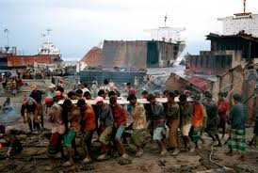
“Shipbreakers” video:
Answer the following questions while viewing the video on shipbreakers:
- How is the purpose of the “shipyards” in Bangladesh different from shipyards in the west?

- How did Bangladesh become a place for dismantling ships?

- Approximately how many shipyards are operating on this 10 mile stretch of beach?

- Approximately how many ships are dismantled in these shipyards each year?

- Approximately how many people are employed in the shipyards and what is their daily wage?

- Why are these shipyards so important to Bangladesh?

- What incentive do shipping companies have for using these yards?

- What would these companies have to do if they dismantled the ships in the United States or Europe?

- What contributes to the “efficiency” of how everything on these ships is “recycled”?

- Why did the owner of the PHP Company purchase a ship for $14 million that is being “retired”?

- How can he make a $14 million purchase sight unseen?

- Why are some westerners opposed to what is taking place?

- What incentive do workers have to undertake this difficult job?

- Why do children take these jobs and how can their employers justify using them?

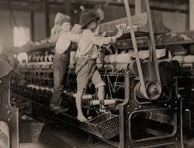
- Compare and contrast this current use of child labor illustrated in this video with that in the United States during the 1800s?

- Use opportunity cost to explain why the crew left pots of food in the dining room of the Russian ship.

- If this operation is violating various laws, why do you think the government permits it to continue?

- Use opportunity cost to defend the actions of the employers.

- Why is it actually more “efficient” to have this work performed on this coast than in the US, Russia, or Europe?

Paper Plane Specialization Activity:
Paper airplane activity:
- How did our paper airplane activity illustrate the advantage of specialization?

- How might businesses use specialization in the workplace to improve productivity and efficiency?
  - Data Processing:

  - Assembly line:

  - Accounts receivable:

  - “Experts”

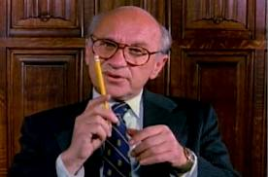
- What is a market?

- What is the advantage of markets?

- How do markets encourage specialization?

- How did the video on “pencils” illustrate specialization?

- How did the video illustrate the role of markets in bringing resources together?

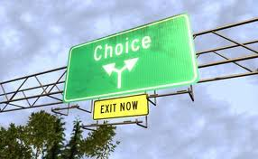
Lesson 14
Thinking at the Margin
(60 points)
Review:

- What occurs in the factor market?

- What occurs in the product market?

- What are normal goods and examples of stores that sell them?

- What are inferior goods and examples of stores that sell them?

Key Terms:
- Thinking at the margin?

- Marginal benefit:

- Marginal cost:

- Net marginal benefit:

- Law of diminishing returns:

- Sunk costs

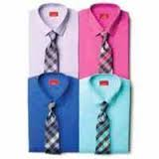
Introduction:
- When I go shopping at a Macy’s “One Day Sale”, when given 6 shirts as trade offs, how do I decide which shirt to buy?

- If I decide to purchase a second shirt, how do make this choice?

- What can I say regarding the “value” I assign to these two shirts?

- How does a sale offering a second item at half price reflect this reality?

- What can we say if after selecting two shirts to buy I decide to buy a pair of purple socks?

- BTW, why is there a round Macy’s in Queens NY?

- Why does Macy’s principal store in Manhattan look like it has a slice missing?

Eating “Love Strawberries”
- What is scarcity?

- What methods can we use to allocate scarce resources, in this case Lopez’s love strawberries?

- In our recent “Ice Activity “, what two methods did we use?

- Of the two methods used in that activity which was most beneficial to our “society” and why?

- How does this method get the product or resource to the person that values it the most?

- Why are we eating strawberries today?

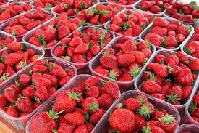
Spraying Strawberries Activity:

Number of Hires | Total Benefits  (Total $ Crops Saved) | Marginal Benefits (MB)  ($ of add’l crops saved) | Marginal Cost (MC)  ($ of add’l hire) | New Marginal Benefit  MB-MC=NMB
1 | $100 | $100
2 | $200
3 | $270
4 | $330
5 | $382
6 | $420
7 | $450
8 | $460
9 | $460
10 | $455
Class notes:
- What occurred during this activity?

- What does “thinking at the margin mean”?

- What is marginal cost?

- What is marginal benefit?

- How can we use marginal cost/benefit in decision making?

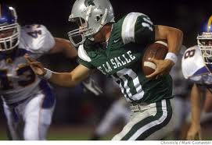
- Using football as an example of thinking at the margin?

- Using store hours as an example?

- At what time do you close your store or restaurant?

- Use studying for an exam as an example?

- How do we determine how many additional troops to send to Afghanistan?

- How do we determine how many days to remain in Afghanistan?

- By staying in Afghanistan, what can we say about the cost in lives and wealth?

- Why is North Korea and Iran attempting to build atomic weapons?

- What is the Law of diminishing returns?

- What are some examples of the Law of Diminishing returns?

- What is the connection between thinking at the margin, satisfaction, and trade offs?

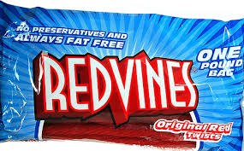

- How did we use candy to illustrate the Law of Diminishing Returns?

- What other examples did we use?

- How did we use candy to illustrate the connection between thinking at the margin, satisfaction, and trade offs?

- How many times did we spray the strawberries?

- How did we make this decision?

- How did this activity illustrate the Law of Diminishing Returns?

- For each of the following use marginal benefit/marginal cost to determine:
  - How many days we should bomb a German city during World War II?

  - How many face lifts should a person receive?

  - How many seat belts or air bags to include in a new car?

  - How much should we spend cleaning up pollution?

  - How often to date a person?

- Why isn’t Mr. Lopez concerned over cuts in Federal Homeland Security Funding to NYC?

- Why is it actually less “satisfying” to increase funding for government programs?

- Why does Mr. Lopez advise never ordering Lobster on a first date?

- What kind of dates do the people on “The bachelor” go on?

- Why is the opportunity cost of these dates “low”?

- Why might these dates make a long lasting relationship more difficult once the show is over?

- Why do children generally increase the marginal benefit of a marriage?

- What is the relationship between thinking at the margin and opportunity cost?

Side Note: In Oakland: Bakesale Betty’s
5098 Telegraph Ave, Get off 24 at Telegraph go left 4 or 5 blocks on left side.
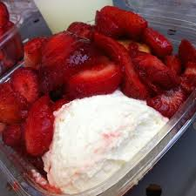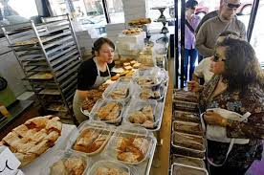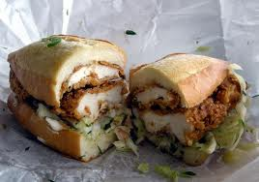

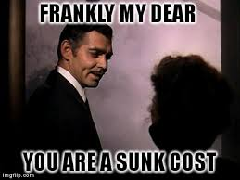
Lesson 15
Sunk costs
(25 points)
Review:
- What does thinking at the margin mean?

- What is marginal cost?

- What is marginal benefit?

- How do we use MB and MC in decision making?

- What is the law of diminishing returns?

- How did we use students to illustrate the law of diminishing examples?

- Why not order lobster on a first date?

- What are sunk costs?

New key terms:
- Utility

Sunk cost activity:
- What was being auctioned?

- At what price did the bidding start?

- What was the reason for the initial bids?

- At what point did the bidding become a losing proposition?

- What was the incentive for why the participants continued bidding?

Class notes:
- How can sunk cost be an incentive?

- What is an example of how sunk costs can be a disincentive to “cheat”?

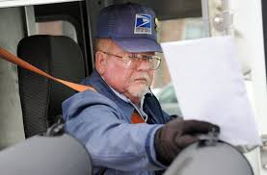
184. What is an example of how sunk costs can be a disincentive to change careers?

- Why do some people stay in a “bad” relationship or marriage?

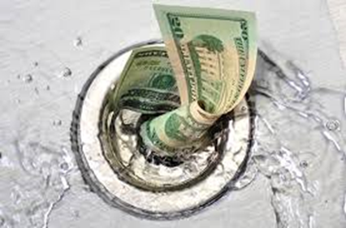
186. What is an example of how sunk costs can be an incentive for government spending?

187. Why do some economists believe The Head Start Program is an example of this?

188. Why is military spending on weapons systems sometimes also an example of this?

189 . How can the concept of sunk costs be used to explain why the US might be staying in Afghanistan?

190. Use sunk costs to explain why the President recently sent 300 plus soldiers back into Iraq?

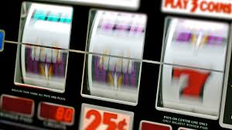

191. How does this demonstration also illustrate situations that commonly occur in casinos?

- How does a company know how many additional works to hire on an assembly line?

