Unit 2

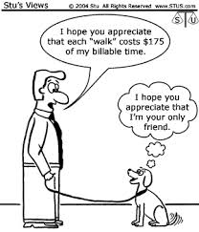
Trade-offs & Opportunity Cost

Class notes:
- What are Trade-offs?
- What is Opportunity cost?
- What does the term Guns or butter refer to?
- What is meant by Probability?
- What is meant by a Possibility?

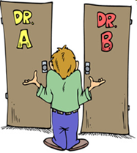
Activity 1: “The Road Less Traveled”, by Robert Frost

Introduction: Every choice has a cost because choosing to do one thing entails giving up the opportunity to do something else. Faced with the same option, different people often make different choices because they place different values on each alternative’s cost and expected outcome/benefits.

The Road Less Traveled

Two roads diverged in a yellow wood,
And sorry I could not travel both
And be one traveler, long I stood
And looked down one as far as I could
To where it bent in the undergrowth;

Then took the other, as just as fair,
And having perhaps the better claim
Because it was grassy and wanted wear,
Though as for that the passing there
Had worn them really about the same,

And both that morning equally lay
In leaves no step had trodden black.
Oh, I kept the first for another day!
Yet knowing how way leads on to way
I doubted if I should ever come back.

I shall be telling this with a sigh
Somewhere ages and ages hence:
Two roads diverged in a wood, and I,
I took the one less traveled by,
And that has made all the difference.

Class notes: Continued
- What is the subject of Robert Frost’s poem “The Road Not Taken”.
- What is the basic choice being required?
- On a more deep reality, what does each choice actually represent?
- Where is the opportunity cost in this situation
- What are some examples of trade offs cited in today’s power point?
- Can you think of any other trade offs that the students in the power point had?
- How was Brad Pitt’s love life used as an example of opportunity cost?
- How did the power point use a trip to Abercrombie to illustrate trade offs and opportunity cost?
- What is an example of a trade off that you recently had?
- What was the 1st decision you made this morning?
Opportunity Cost Analysis
Decision Maker: YOU

Alternative | Get Up Now | Don’t Get up Now
Perceived benefits

Choice

Opportunity
Cost
Benefits
Refused

- How was this decision rational?
- What is the opportunity cost associated with your being in this class today?
- Why was the opportunity cost of Mr. Lopez attempting to save $7.00 by stopping at the Danville library to read the Sunday New York Times while driving from Lafayette to San Ramon to swim at Cal HS relatively low?

- Use opportunity cost to explain why a typical student in Mr. Lopez’s class is less likely than Mr. Lopez to drive to the Danville public library?
- Use the idea of choosing a date for the senior ball to illustrate the concepts of trade offs and opportunity cost?
- How did Mr. Lopez use a choice between a blond and red head to illustrate opportunity cost?
- How did Mr. Lopez use the possibility of dating either Shakira or Enrique to illustrate opportunity cost?
- Why will Mr. Lopez’s dating Shakira or Enrique never be an opportunity cost for Mr. Lopez?
- Why is there very little opportunity cost in using ladies with scissors to trim the lawn at a monument in North Korea or India? ( In North Korea: http://www.youtube.com/watch?v=YZAp7gWWANI)
- How can opportunity cost explain why a female immigrant is more likely to have a larger family (more children), than a female who graduated from law school and is an attorney?
- What changes in family size would economists expect to see in a society with improving education and employment opportunities for women?
- How can opportunity cost explain the changes in family sizes in Spain?
- How can opportunity cost explain why Mr. Lopez could not get a decent banana in Spain when he was younger?
- Why did the quality of bananas in Spain increase during the 1990s?
- Why is there very little opportunity cost in the Oakland A’s donating Wednesday night tickets for a game against the Diamondbacks to orphans?
- Why is there very little opportunity cost in the NY Yankees donating hot dogs and hamburgers after the 8th inning to a local soup-kitchen?
- What is the relationship of wealth and income to opportunity cost?

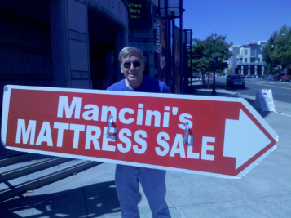

- What is the “Mattress Plan” and how does it relate to opportunity cost?
- How is using a credit card when purchasing goods and services an example of the “mattress plan”?
- How is the US fighting the wars in Iraq and Afghanistan on the “Mattress Plan”?

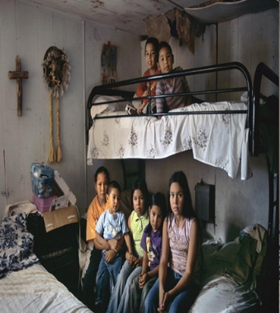

- Use the definition of economics to explain why individuals immigrate to countries such as the United States and Spain?
- Where does opportunity cost enter into their decision to emigrate?

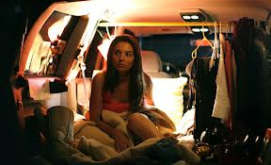

- What is a free transaction?
- What are trade-offs?
- Household:
- Business:
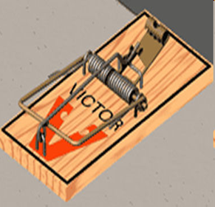

- How did Mr. Lopez use a mouse and a rat trap to illustrate opportunity cost?
- How did Mr. Lopez use two candy bars to illustrate that nothing is free?
- Use opportunity cost to explain why nothing is free.
- How did Mr. Lopez use five candy bars to illustrate the concepts of trade offs and opportunity cost?
- In discussing the illustration using five candy bars, why was it easier to determine the trade offs than opportunity cost?
- Use the TV show “The Bachelor” to explain the difference between trade offs and opportunity cost?
- Use the show “Survivor” to explain the difference between trade offs and opportunity cost
- Use the Miss America Contest to explain the difference between trade offs and opportunity cost?
- What is the opportunity cost when a student leaves this class to go to the rest room?
- Given your answer to 20 above and the definition of economics, what can we say regarding a student that leaves the class for a rest room break?
- How do hospitals use opportunity cost in allocating their scarce resources in the emergency room?
- Use opportunity cost to explain why it was almost certain that the site of the World trade Center would be rebuilt upon after 9/11.
- How can opportunity cost explain why land in San Francisco is more valuable than land in Brentwood?
- Use opportunity cost to explain why the centers of most US cities have skyscrapers?
- Why more people choose to live in San Francisco than Brentwood.
- How does Mr. Lopez not accepting a “free” weekend in Las Vegas illustrate that the trip is not actually “free”.
- Use opportunity cost to explain why a lower income person is more likely to smoke than someone with a higher income
- Use opportunity to explain why a highly paid executive or an “important” politician is more likely to lie than someone with a lower salary or status.
- Explain why someone would be willing to wait a long time in line for each of the following:
  - Prescription drugs:
  - At the DMC:
  - To visit a museum in Florence:
  - To purchase Lady Gaga tickets:
  - To buy the latest Harry Potter book:
- Use opportunity cost to explain:
  - Why a highly talented person hires a chauffeur:
  - Why business people fly first class when traveling for the company but economy when going on vacation:
  - Why farmers wait till its raining to go into town:
  - Why movie stars and rock musicians have higher divorce rates:
  - Why students in eastern Europe are less likely now than they were in 1985 to do their homework or study:
  - Why Americans today feel more “pressed” for time then their grandparents did:

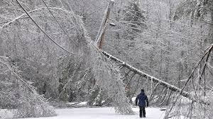

Lesson 8
“The Ice Activity”
(40 points)
Review:
- Why can it be said that nothing is free?
- Why didn’t Mr. Lopez accept a “free” trip to Las Vegas?
- How does a hospital use opportunity cost to allocate its scarce resources?
- Why can’t Mr. Lopez say his opportunity cost of being here today is a date with Shakira or Enrique?
- What is the “free transaction”?
- How does a free transaction assure that both parties are satisfied?
- What is a household?
- What is a business?

Into to Activity:
- What products are generally in greater demand during a blizzard?
- What products are generally in greater demand before a hurricane?
- What occurred in New York City that resulted in many people sleeping in the streets?
- Use opportunity cost to explain why these individuals made the choice that they did?
- How might individuals and/or businesses attempt to “take advantage” or “profit” from these kinds of situations
- Can any argument be made in support of those seeking to “profit” this way?
- Why were people able to purchase water and pizza late in the night?
- What motivation did the sellers have in selling these items late into the might and what extra costs might they have faced in staying open through the night?
- What does Wal Mart do when they predict a storm is heading for Florida?
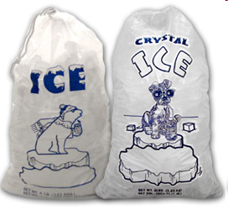
Class Notes: The Ice Activity
- . Describe what occurred during this activity.
- What methods can be used to allocate scarce resources?
- What methods were used in class
- Compare and contrast the values derived from the methods used in class?
- Why or why not do you believe that the first method were the most worthy?
- How was the concept of opportunity cost a factor for individuals during out first round?
- Why did opportunity cost decrease in the second round?
- Why did one method have the effect of increasing the supply of ice?
- How did the increased price in the second round bring demand and supply together?
- Why is price the best method for allocating a scarce resource?
- What substitutes could a person have used for ice?
- Why can it be said that price gouging actually benefits society during a crisis?
- What happened to the price of gas, lumber, hotel rooms etc in Louisiana after Katrina and in Florida after storms there?
- Why did some people complain afterwards?
- What did some politicians do as a result of these complaints?
- How do economists view these price increases and how can they be defended?
- How did “greed” allocate resources such as gas or lumber to those who really needed it?
- How did “greed” better allocate our ice during our activity?

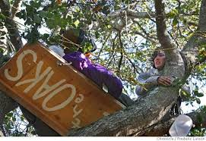

- Why might an individual pay a really high or “unreasonable” price or opportunity cost?
- Why can it be said that in economics, sometimes 3 + 2 = 6? How is this possible?
- What are other examples of this unknown variable?
- In these examples, if the individual did not “need” to make the choices they made, then what must be true?
- Therefore in attempting to understand the unknown variable or explain what might appear to be an unreasonable choice what show we ask?

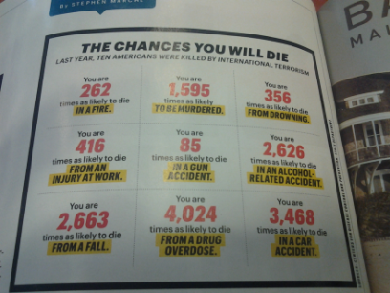
Opportunity cost and airline and school safety

- What is the difference between possibility and probability?
- Given that there is scarcity, which is a better choice, one that is possibly satisfying or one that is probably satisfying?
- Why would it be a bad choice for Mr. Lopez to pass up a date with the Safeway butcher waiting for Shakira or Enrique to call and ask him out?
- Why is it sometimes true in economics that 3+2=6?
- What must we look for in understanding what that equation is true?
- What is the key to understanding behavior and choices individuals sometimes make that appear to be unreasonable?

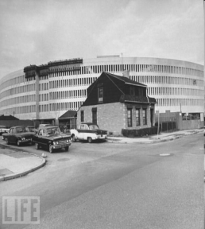
- Use opportunity cost to explain why students were more likely to pick up a quarter then they were to pick up a penny or nickel.
- Use opportunity cost to explain why someone is more likely to purchase a candy bar from me for a nickel then they are for a dollar.
- How did opportunity cost and the concept of a free transaction result in a round Macy’s in Queens NY?
- Why wasn’t this a new issue facing Macy?
- How is Mr. Lopez’s obsessive spitting on Gimbels an example of the unknown variable?
- How can we explain why Mr. Lopez believes this is a reasonable choice?

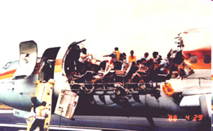
Airline safety discussion

- Which of these should we be more concerned about a probability than about a possibility?
- How does opportunity cost influence our choices?
- Why is the difference between possibility and probability important in determining how to use scarce resources?
- What were the safety proposals and the cost of each of these proposals that were being considered for the airline industry?

a. ____________________ cost per ticket:___________

b. ____________________ cost per ticket:___________

c. ____________________ cost per ticket:___________

d. ____________________ cost per ticket:___________

e. ____________________ cost per ticket:___________

f. ____________________ cost per ticket:___________

g. ____________________ cost per ticket:___________

h. ____________________ cost per ticket:___________

- Which three of these proposals were more likely than the others to be adopted and why?
- What is the relative opportunity cost of those likely to be adopted?
- Which proposal do you think was the least likely to be adopted and why?

